Oki! Hello! Bonjour Tigers! We are looking forward to welcoming you back to school next week. We know you have some questions about the beginning of school, so we wanted to share some information.

Grade 6 Open House - August 29th from 12 – 2pm
We will be hosting an open house for all new to GPMS and grade six students on August 29th from 12 – 2pm. Grade 6 students are encouraged to drop by during this time to visit the school again and look around, meet our staff and pick up some information and their locks to practice at home. (Students need to bring the locks back to school on their first day.) Please meet for tours at the front doors of the school. Students will NOT receive their timetables on this day.

Bell Times
Our bell times have altered slightly from last year. Please note the new times below.
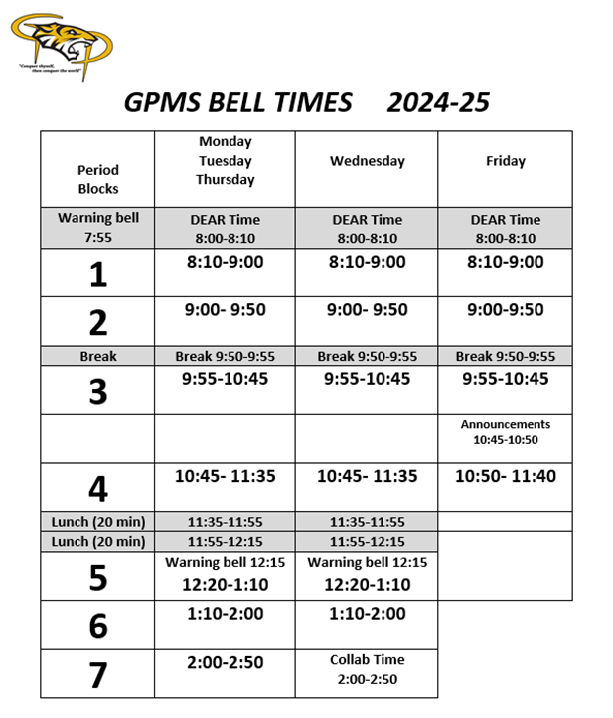

Busses
We will once again have many yellow school busses bringing students from all over Lethbridge to attend Paterson. It does take some time to get an official pass to every student who rides a bus. It is our understanding that busses will run starting on September 3rd and that no student will be turned away until passes have been confirmed. Please be patient with us as we work with Southland Transportation to take care of our students.
Please note that there is a new process for getting a bus tag this year. If you have not completed the request process through PowerSchool please click on the link below.
https://www.southland.ca/lethbridge/

PowerSchool
PowerSchool will be open on Friday, Aug 30th at 12:00PM for parents and students to view class and option information. Families will also receive an email welcoming them from their core teachers on this day that will contain information on where to go on the first day of school. If you have any questions about PowerSchool please contact the school.

Option Changes
Middle school options are meant to be exploratory, meaning we hope students will try new things! Please know that even though students made option selections, these selections are not guaranteed. Option changes are difficult but can be accommodated if there is room in other options. These will be done after school starts and students have had the opportunity to try their assigned options. Starting on Sept 6th, you can contact your grade level administrator if you require an option change. Changes will run from Sept 6th – Sept 13th.
Grade 6 – Catherine Thorsen catherine.throsen@lethsd.ab.ca
Grade 7 - Pierre Legal pierre.legal@lethsd.ab.ca
Grade 8 – Morgan Day morgan.day@lethsd.ab.ca
Please remember these are for options only, we cannot accommodate any homeroom changes.

First Day of School – Staggered Entry
ONLY Grade 6 students will start on Tuesday Sept. 3rd and will have a full day. Students will need a lunch the first day. ONLY Grade 7/8 students will attend on Wednesday Sept. 4th and will also need a lunch that day (reminder that there is early dismissal on Wednesdays). ALL students attend on Thursday Sept. 5th and regular class schedules will commence.

Lunch
Paterson is a closed campus which means that students must stay at the school during the lunch hour unless guardians complete a form at the main office. If you wish to have your child come home for lunch on a regular basis there is a form in the office that you can complete.

School Messenger
School Messenger is used to excuse students at Paterson. Please download and use the app or go to https://go.schoolmessenger.ca/#/account/login to report all absences. You can also call the toll-free number at 866-879-1041.

School Cash Online
All school fees are paid through school cash online. School fees will not be posted until the end of September. We will send out a note when they are available to be paid.
https://lethbridge.schoolcashonline.com/

Supply Lists
Please see the attached link for a supply list. This basic list will apply for all grades.
https://gp.lethsd.ab.ca/download/457074
School photos
Our school photos will occur on Thursday, September 17th.

Meet the Teacher Night
Our meet the teacher event will be on Thursday, September 12th from 6:30 – 7:30pm. More information will be sent out closer to the event.

